ACR Report Entity SSCUI
Setting Up Your Compliance Reporting

Step 1: Access “Manage Your Solution” App under group “Implementation Cockpit” with user BPC_Expert.
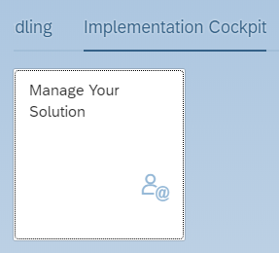
Step 2: Switch country version, e.g. “Malaysia”.
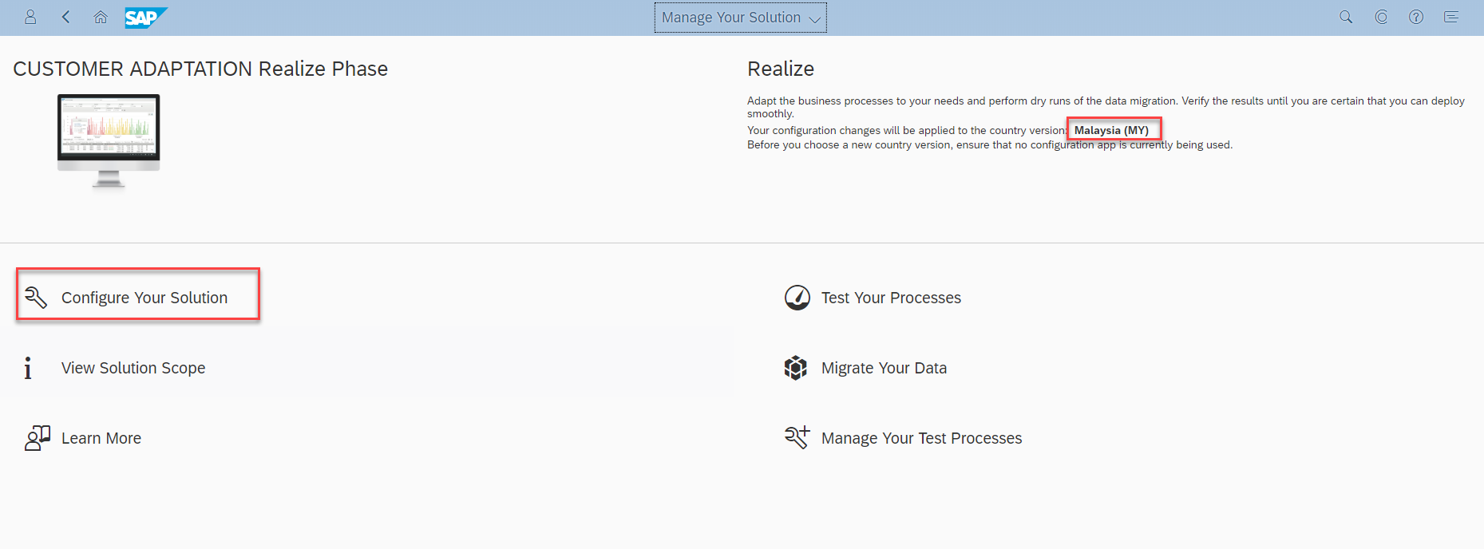
Step 3: Fill Application Area = “Finance” and Sub Application Area = “Statutory Reporting”.
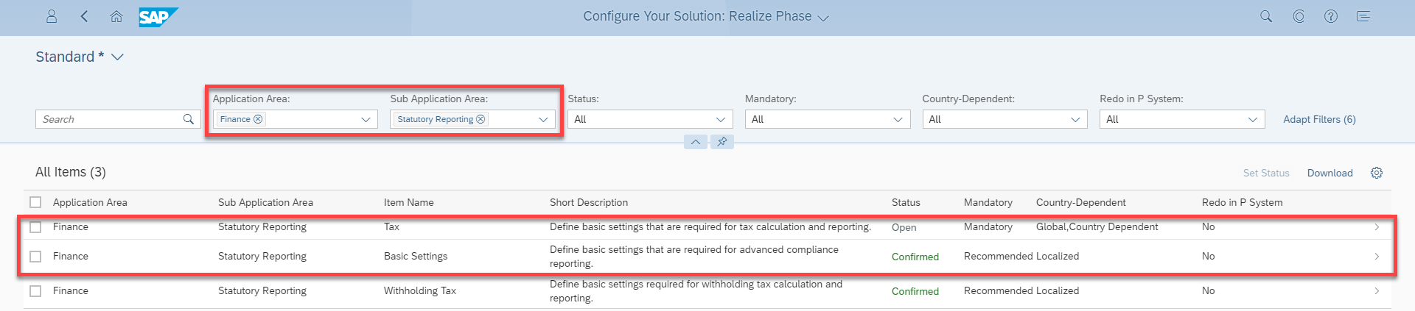

Step 4: Open configuration for activity “Setting Up Your Compliance Reporting”.
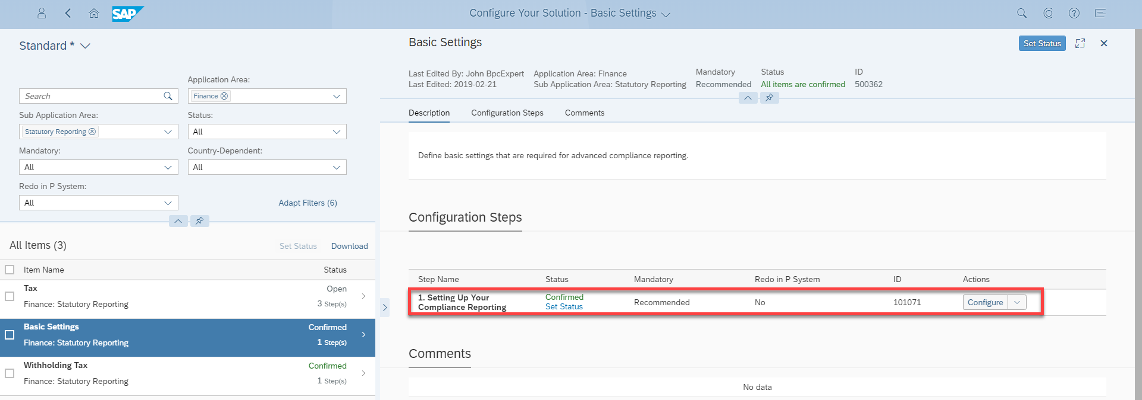

Step 5: Make configuration change in this WEBGUI SSCUI.
