Clean up loginMethod cookie in IE
1. Go to SF domain in IE
2. Click the Tools button , select F12 developer tool
3. Click Cache -> View cookie information
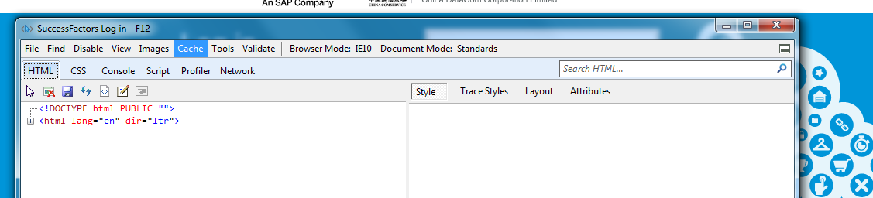
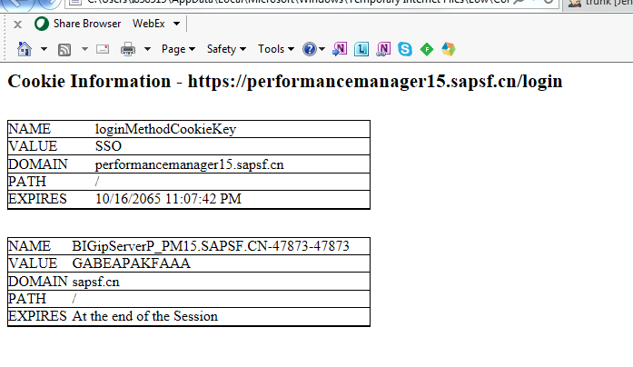
4. If there is loginMethodCookieKey cookie, then click (Cache->clean cookies for domain).
5. Click Cache -> View cookie information, and make sure there is not loginMethodCookieKey cookie.
6. Login

For other versions IE browser, may try:
- Navigate to SF domain, Click on IE browser.

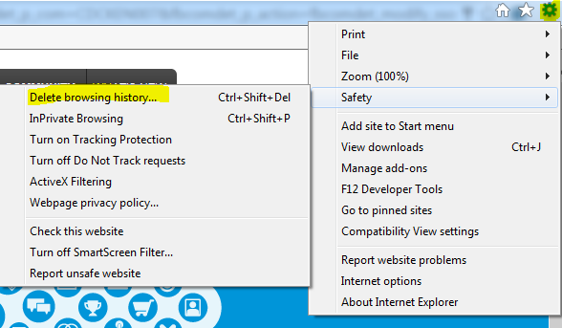

- Make sure the check-box was checked :Cookies and website data, then click “Delete”
Pls note: pls select other check-boxs carefully, such as “Passwords” ,you have to input your credential again once deleted when acces some website next time
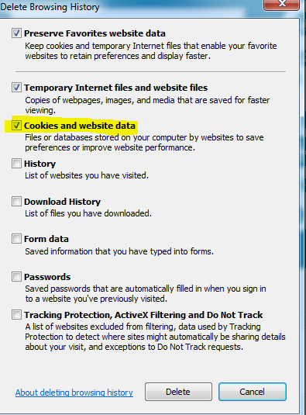

Clean up loginMethod cookie in Chrome
1. Go to SF domain in IE
2. Click the Tools button , select more tools ->developer tools
3. double check cookie

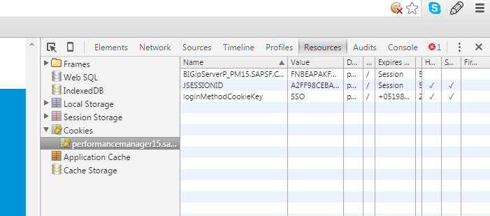

4. Clean up cookie if there is loginMethod cookie.
Or
- Click the lock icon on Chrome browser:
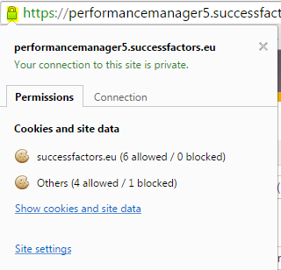
- Click “Show cookies and site data” on the dialog ,another dialog will pop-up, then select the domain and view “Cookies” data.
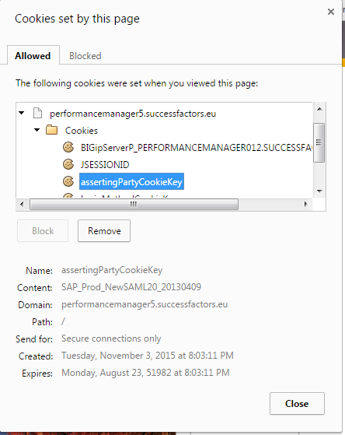

- After view the cookie data, click , and select “History and recent tabs”, then click “History”

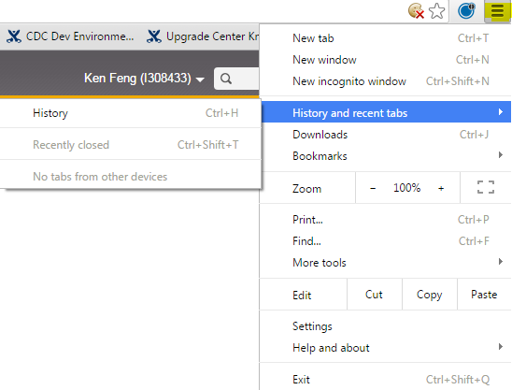

- Click “Clear browser data” button on the pop-up page:
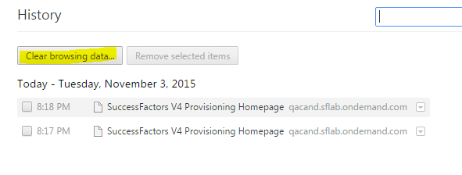

- Select “the beginning of the time” and make sure “Cookies and other site and plugin data” is checked, then click ”Clear browsing data”:
Pls note: Select other check-boxes carefully, such as “Passwords”, you have to input your credential again once deleted when you access some website next time.

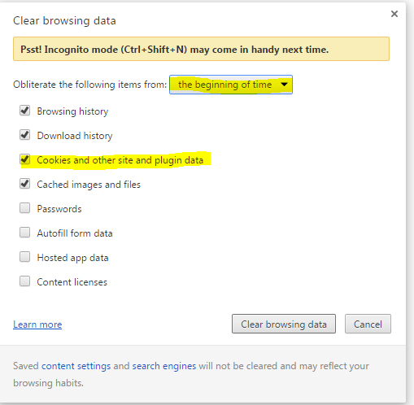

Clean up loginMethod cookie on FireFox:

- Navigate to SF domain, click on fireFox browser:
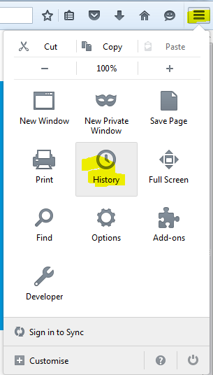

- Click “History”, then click “clear recent history”
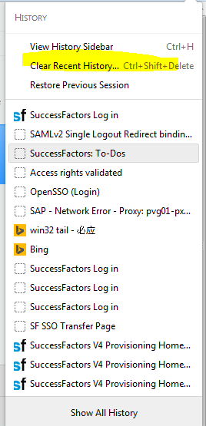

- Select the time and make sure “cookies ” is checked, the click “clear Now":
Pls note: Select other check-boxes carefully, such as “Passwords”,you have to input your credential once deleted when you access some website next time.
