Symptom:
Selecting Analytics Tab return blank or empty page when
Environment:
SuccessFactors Analytics
Cause:
URL not set in provisioning for ‘Authorized SP Assertion Consumer Service Settings’. In this case in the Company Settings: WFA – the SSO was configured and all look fine but when accessing the Analytics tab, it return an empty page. (See the screenshot in replication steps below).
Resolution:
The Support engineer or Engineering team will have to check the setting in provisioning,
- In provisioning instance landing page – select : Assertion Consumer Service Settings:
Verify that URL for login and logout: Assertion Consumer Service and Logout URL are populated (depending on the Data canter):
Example: DC 5/12:
- Assertion Consumer Service: https://analytics012.successfactors.eu/Production/Login.aspx
- Logout Url:
https://analytics012.successfactors.eu/Production/HrmlLogout.aspx

- Also, check: Company Settings ->WFA -> SSO configuration.
Replications steps:
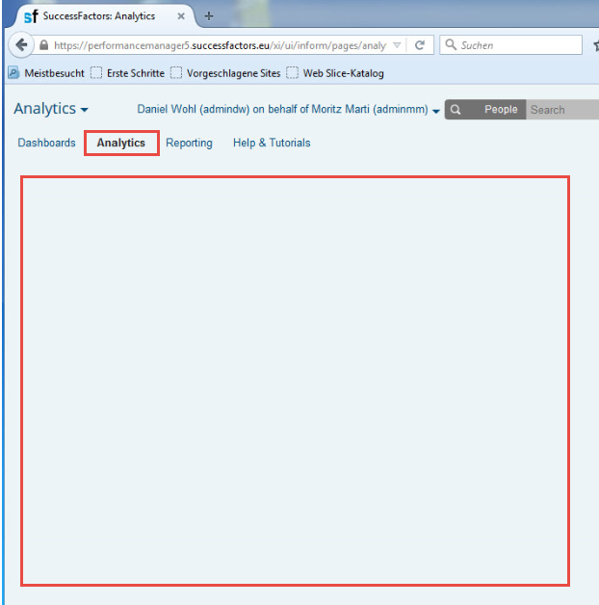
The WFA analytics /ORD looks fine:
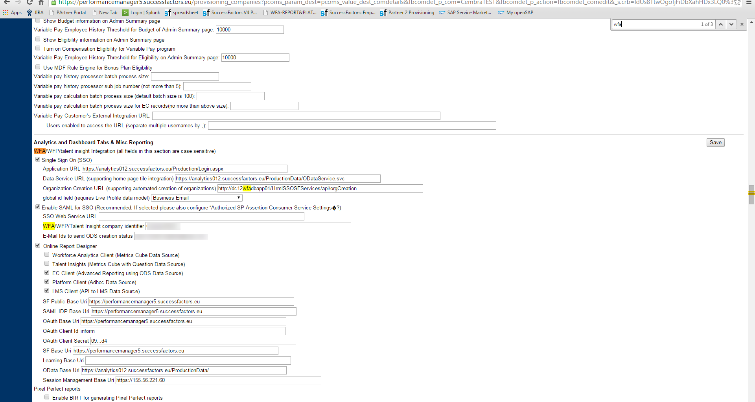
The Workforce Analytics -> Instance not found:
Go back in the provisioning:
Check: ‘Authorized SP Assertion Consumer Service Settings’
Assertion Consumer Service and Logout URL missing as seen below:
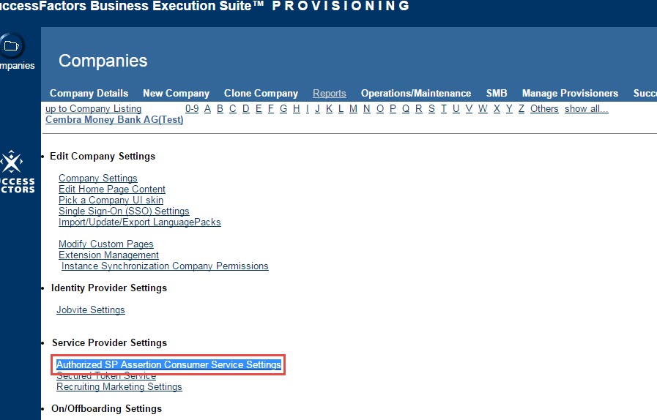
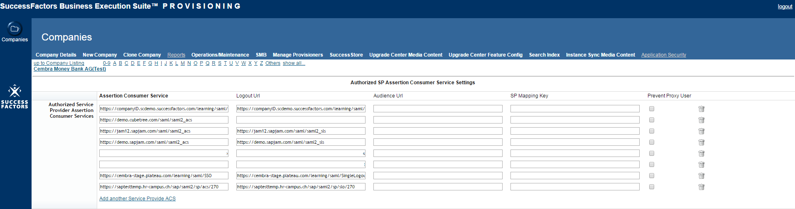
Check in the SSO setting the corresponding DC,
Adding the URL for login and logout: Assertion Consumer Service and Logout URL
Assertion Consumer Service=https://analytics012.successfactors.eu/Production/Login.aspx
Logout Url=https://analytics012.successfactors.eu/Production/HrmlLogout.aspx
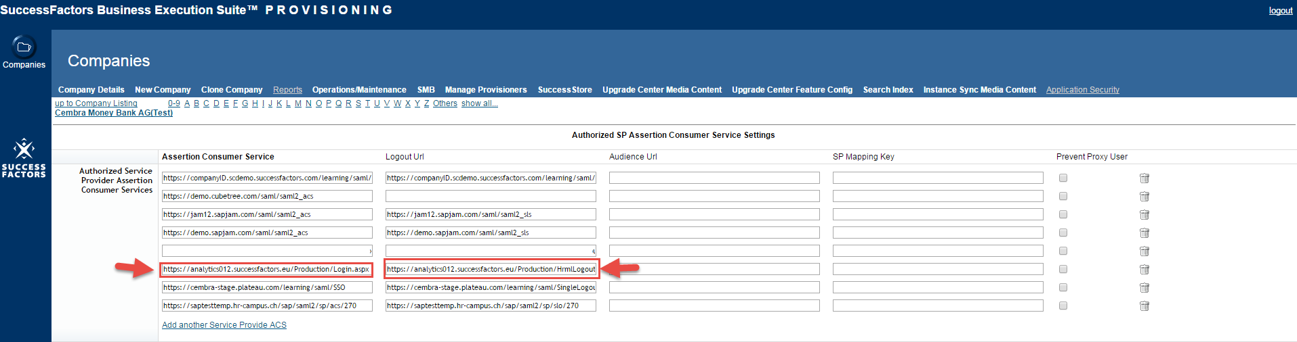

Go Back to BizX -> Analytics -> Analytics: / case 56261 / 2015 / online Report Designer
