Symptoms:
Accruals Continue for Terminated Employees
ENVIRONMENT:
EMPLOYEE CENTRAL: TIME OFF
Reproducing the Issue:
Even though employees terminated, accrual still get posted for the employees. Once an employee is terminated the accrual process should stop.
Employee below is terminated but he still has 86.81 days of vacation. Vacation is also still accruing for the employee.
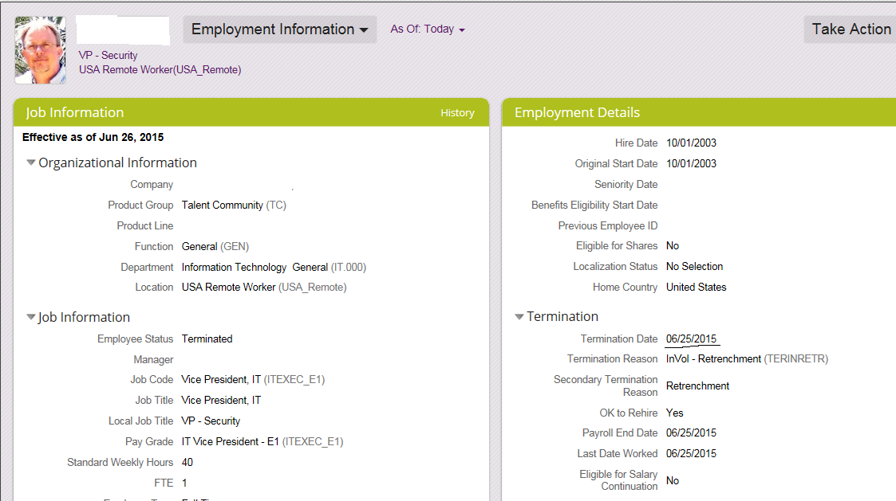
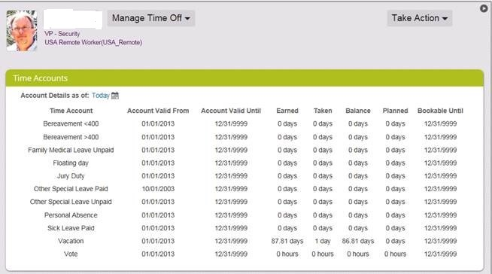
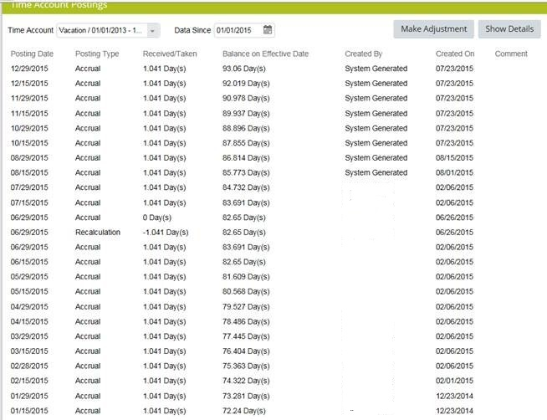
Cause:
The proper configuration on how to handle accruals for terminated, suspended or employees who are not working were not configured. The TLM_Configuration helps to achieve this. The employee’s should get the accruals posted or not depends on the eligibility status. By default the eligibility status is Yes. Therefore, if for any circumstances such as employee is being terminated, the employee should not get accruals posted, then the Time Off Configuration should be set for that.
Resolution:
Setting up Eligibility Status for the employee
The employee’s should get the accruals posted or not depends on the eligibility status. By default the eligibility status is Yes. Therefore, if for any circumstances such as employee is being terminated, the employee should not get accruals posted, then the Time Off Configuration should be set for that.

Setting up Time Off Configuration
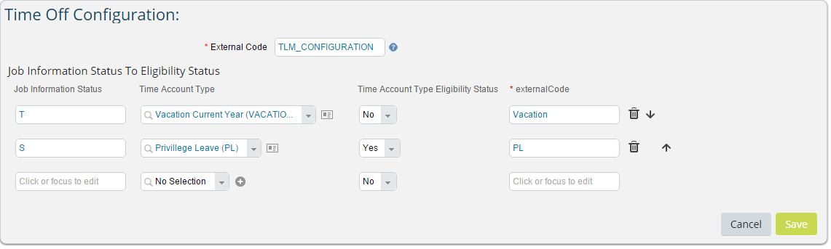
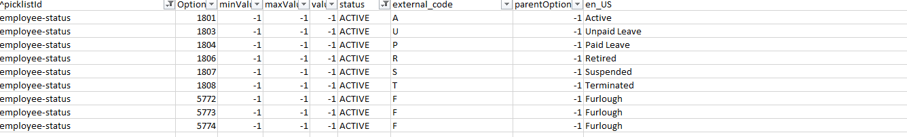
S. No. | Field Labels | Values
1 | External Code | Should be TLM_CONFIGURATION
2 | Job Information Status | Terminated or any other Employee Status displayed under Employment Information. External Code of the Employee Status from employee-status picklist. Here, T for terminated, S for Suspended.
3 | Time Account Type | Time Account whose eligibility needs to be set
4 | Time Account Type Eligibility Status | Yes – For accruals to be posted.  No – For accruals not to be posted.
5 | externalCode | Any values of your desire to identify for each associated Job Information Status- Time Account Type combination.

After creating the Time off Configuration, save the changes. Based on the configuration the accruals for the employees will be posted.

