Copy the table from excel sheet to the word document
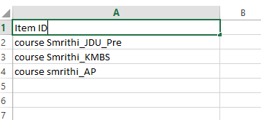

While pasting into word, keep the Paste Option to Text Only
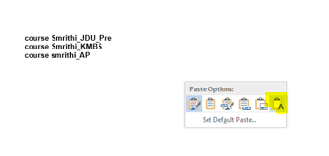
Then in the keyboard, perform the below step by step:
- Ctrl + A
- Ctrl + H
- In Find What field type without inverted commas ‘^p’ and in Replace With field type without inverted commas ‘,’
- 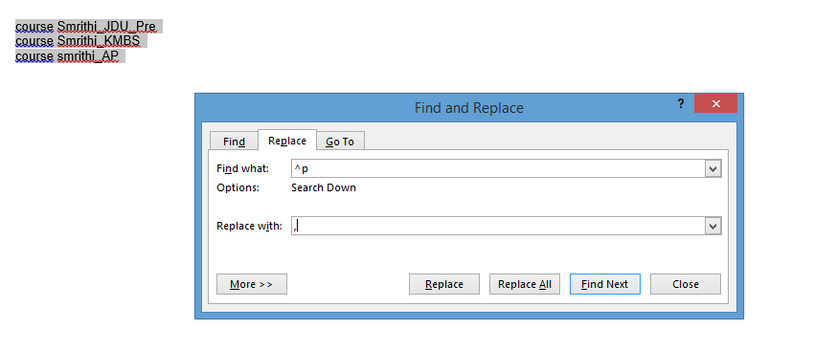
- Then click on Replace All, it will give you the output in separated commas as shown below

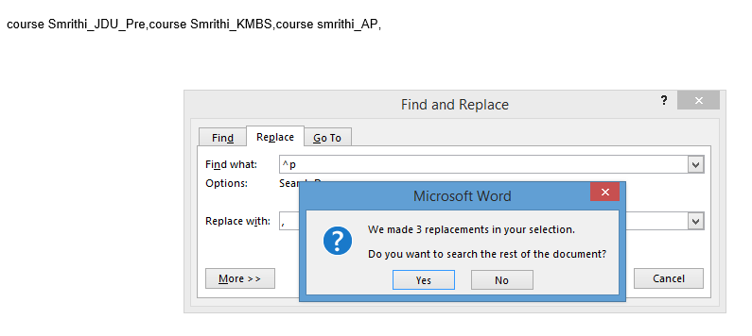
Click on Yes

