How to turn on Platform feature
Login to Facebook account, in home page, click drop down and choose Settings.

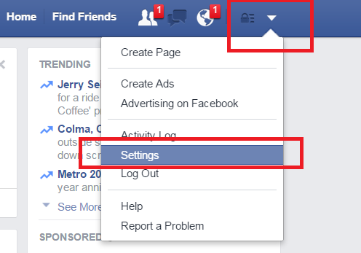

Then choose Apps
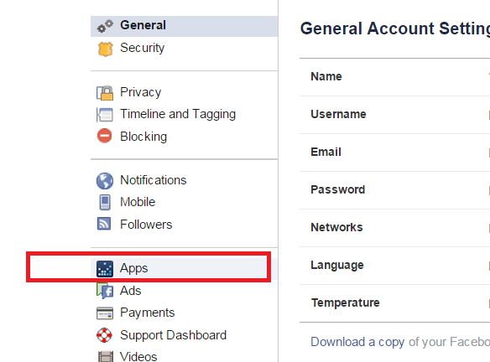
Then click Edit button in Apps, Websites and Plugins block
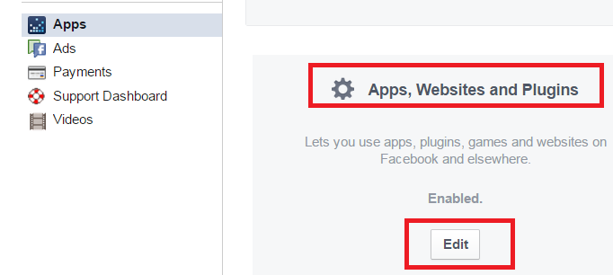

Make sure Platform is on. If it is off, please ask the customer to turn.

