The report TENANT_TIMEZONE_CHANGE only provides the list of timezones of the countries, which are scoped in the customer system.
The requested time zone GMTUK belongs for example to the country “GB” (Great Britain).

When the report is executed, it reads the scoped countries and writes it into a table, which is used to create the list of available time zones for the dropdown list of the new timezone.

So the solution is to use the debugger and to add “GB” into this list while the report is executed. Then the requested timezone will be available in the dropdown list.

Here is a description of what you have to do:
Display the content of the report TENANT_TIMEZONE_CHANGE (e.g. via transaction se38)
Double click on “tenant_timezone_change_set_o01” in order to open it
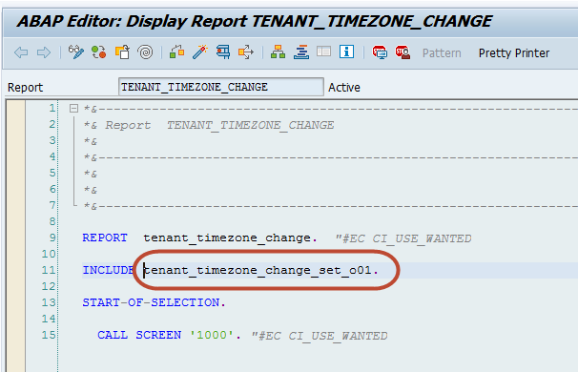

Scroll down to line 150 and double click on ‘TIMEZONE_DROPDOWN_LIST’ to this function.
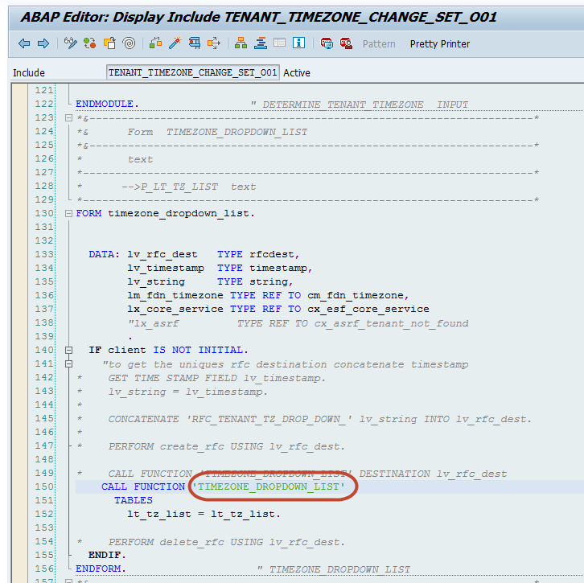

Set a breakpoint in line 35 of the function module TIMEZONE_DROPDOWN_LIST:
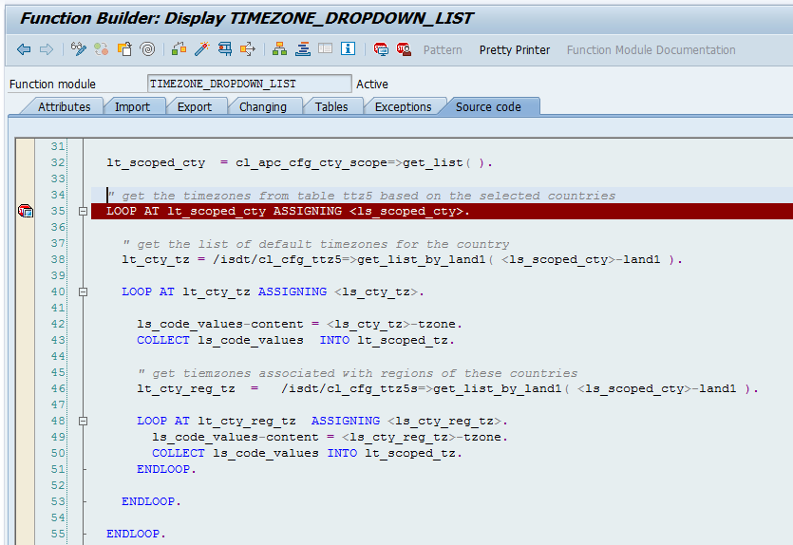

Then start the report.

When the breakpoint is reached, double click on the variable LT_SCOPED_CTY in order to open this table of the scoped countries
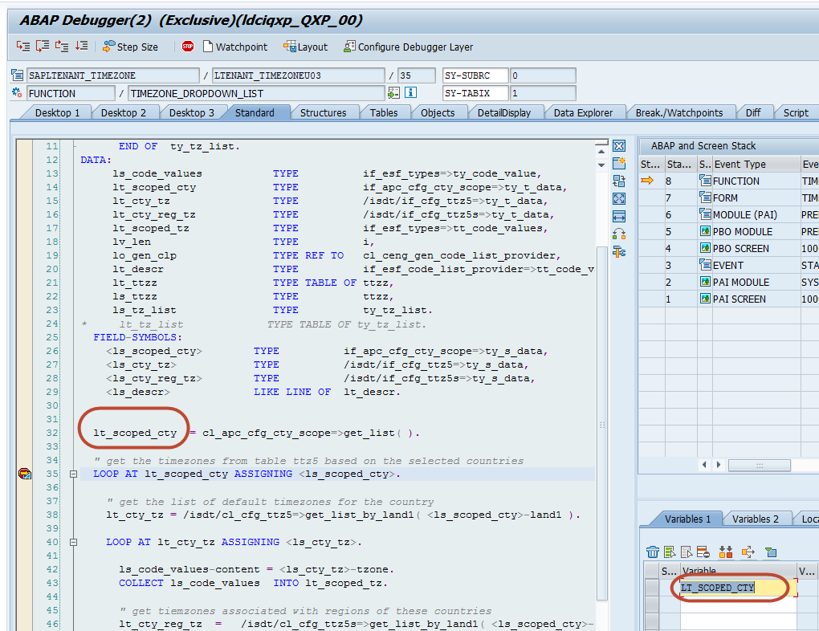

After you have opened the table LT_SCOPED_CTY, click on the tool on the right side (hammer icon) and then select “Append Row (APPEND)”:
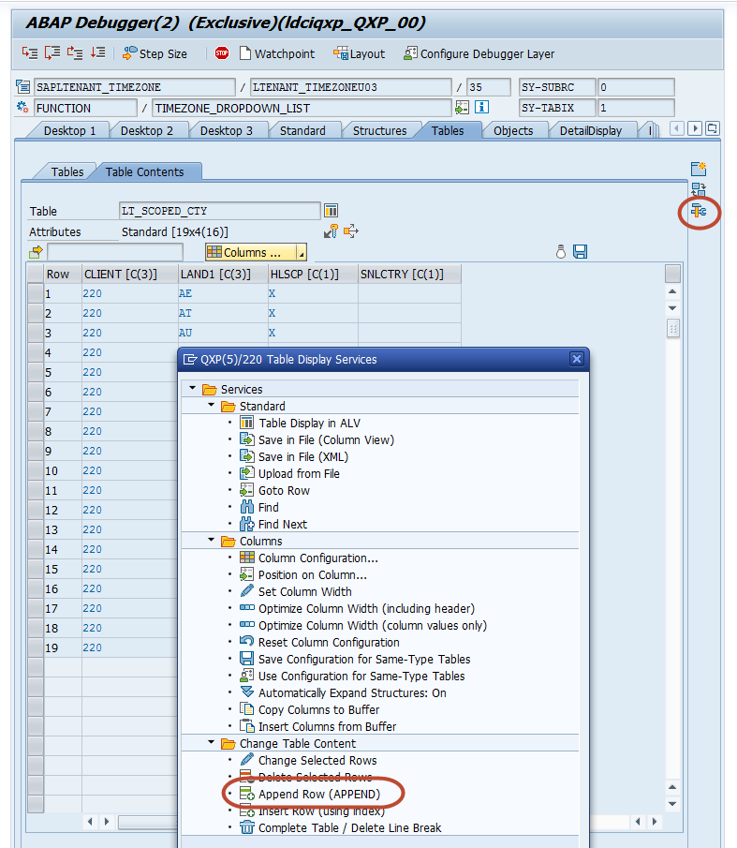

Accept the “Append Row” popup window with Table Row = 1:
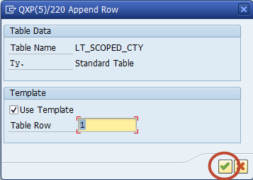

Then you can add a new line to the table. It is prefilled with another record from the table (in the customer system the client will be different from my screenshot). You should not change the client and only enter “GB” into the column LAND1 at the second line. Then press the return button on the keyboard. You should then get an info message “New line inserted with index X”.
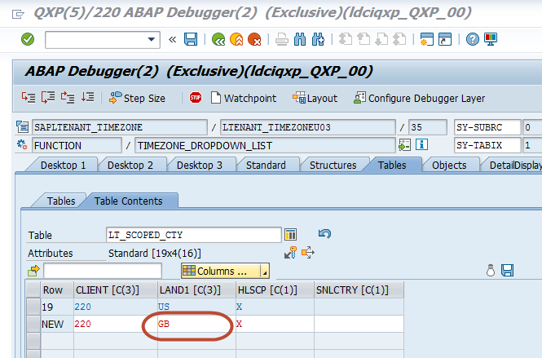

Then use the green arrow to navigate back.
You can check that the new record with “GB” has been added to table lt_scoped_cty.
Then continue report execution by pressing F8. Then the requested timezone should be available in the dropdown.

