In this example, we have joined Account Master Data, Territory Team, Account Contact Data and Territory Account Mapping.
The error occurs because there is no join between the first and second data source, and the second and third:
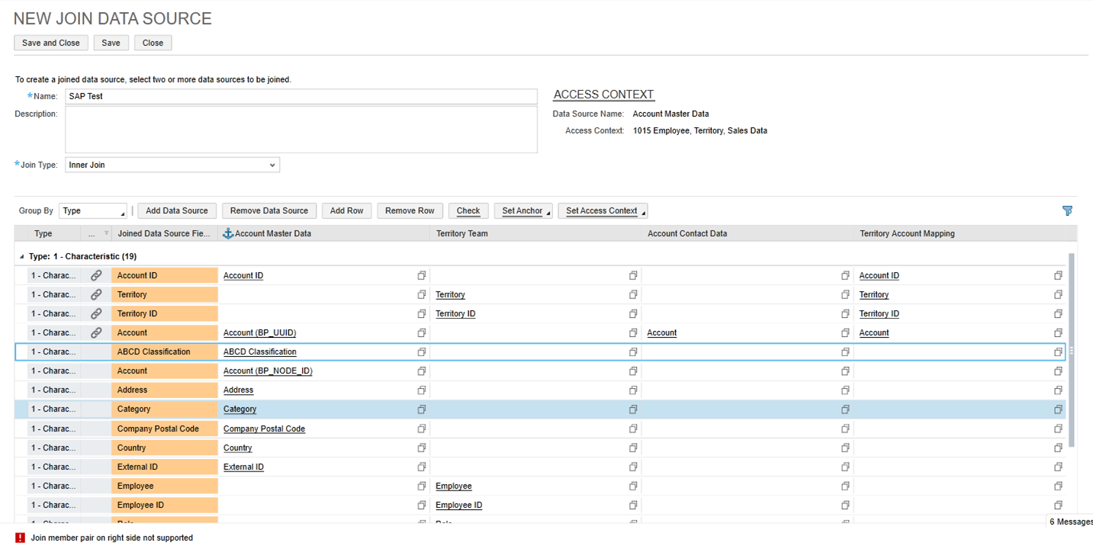

To resolve this, please change the order of the added data sources so that there always is a connection to the previous data source:
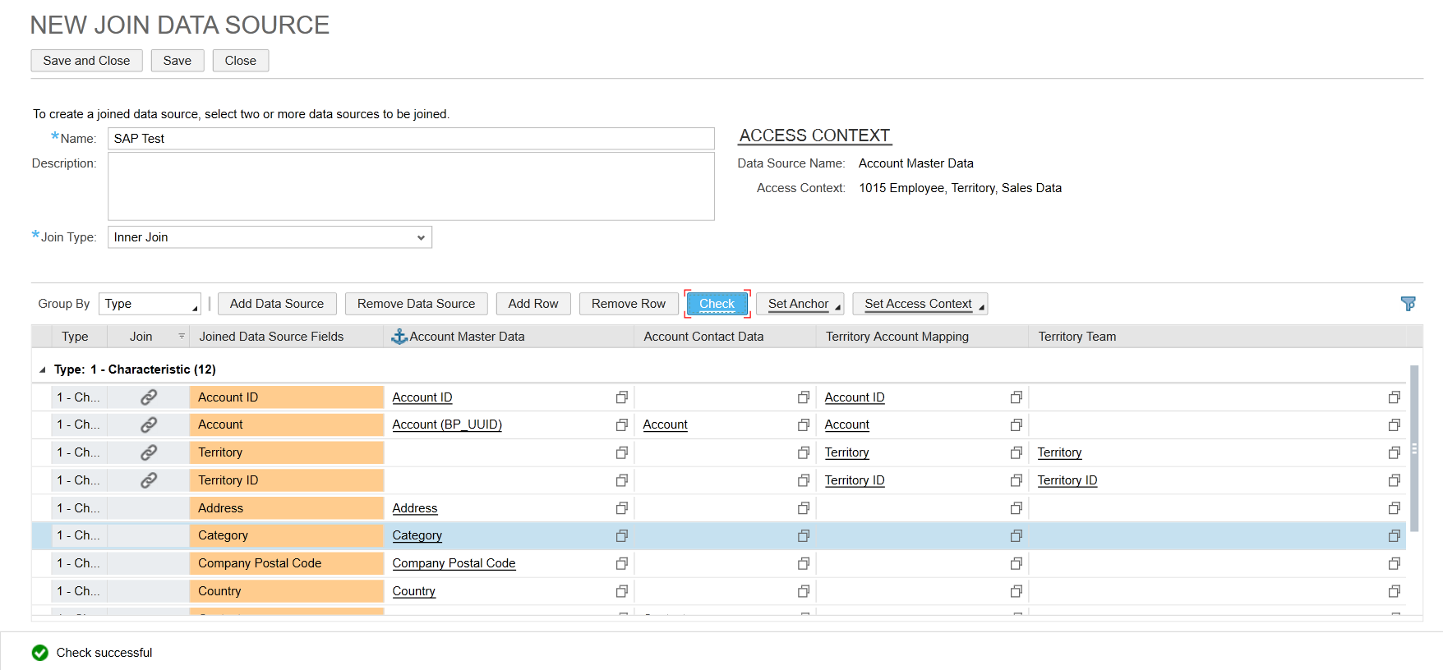

This will ensure that all joins are created correctly.

