SF Mobile Features Issue
The features Touchbase and Time Off are enabled in SF Mobile App features, which is incorrect.
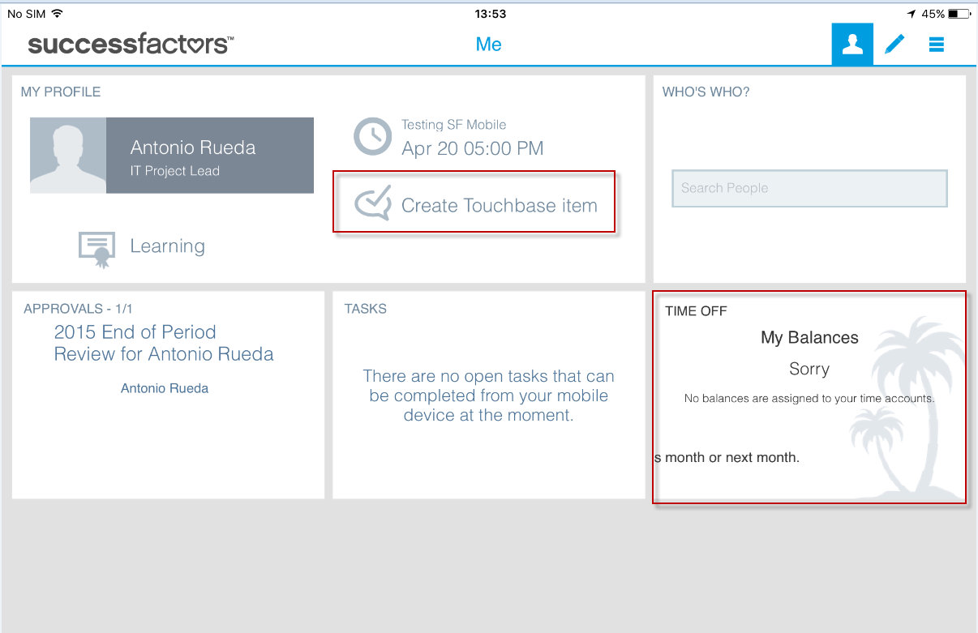

Navigate to ‘Admin tools => Enable Mobile Features’, you can see Touchbase & Time Off features are not enabled.
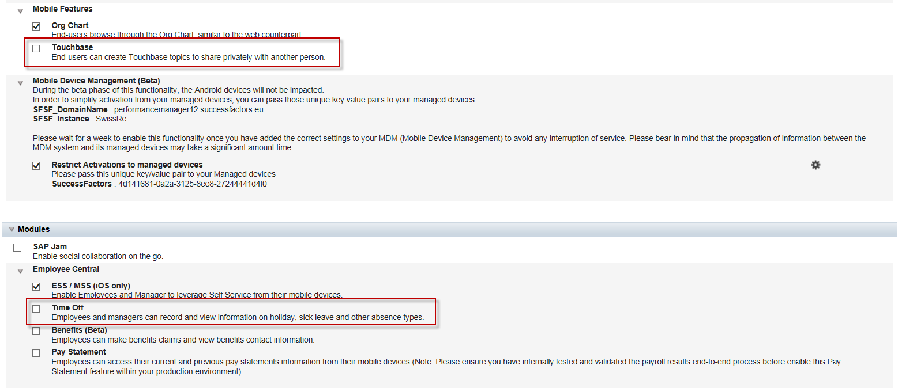

Issue Resolution Steps
From ‘Admin tools => Enable Mobile Features’, first we enabled the Touchbase and Time-Off features. After 10 minutes, we disabled these features.
Now, we do not see the Touchbase and Time-Off feature in the mobile device.

