Mass creation of Employee ID's using Import employee data functionality

Symptom:
In the current scenario customer is facing the following issues mentioned as under:
- While using the Import employee data functionality if we keep the User ID field empty, The process will consider it as an addition and would create a new ID?

- Attached is the excel I used for the process and the email that I received upon completion of the process

Environment: EMPLOYEE CENTRAL: Employee Import

Scenario:

- Customer is performing basic import keeping user id or person id as empty field.
- The file is as below :

- Report:
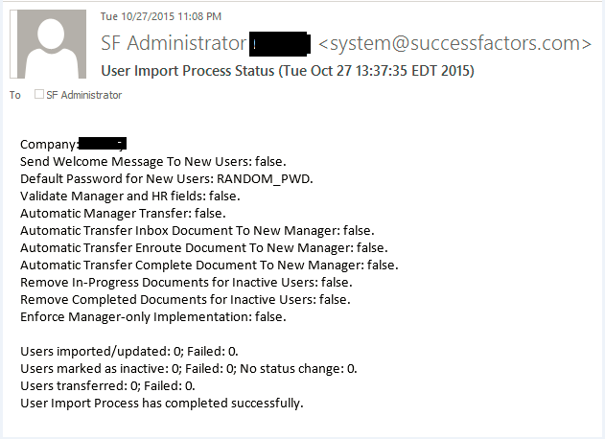

Resolution:

While performing employee upload user id or person id is mandatory. If left blank it will not process the user.

In ‘Add new Hire’ Wizard user-id need not be mentioned, it is generated automatically or customer can specifically mention.
But in employee import (Basic import) it does not generate automatically.

For this enhancement request needs to be raised to engineering.

