Troubleshooting steps:

As a starting point consider a version that has a lot of zero values on leaf accounts and time dimension members.
Note that the data actions below only affects base facts and not the aggregations that sum up to 0.

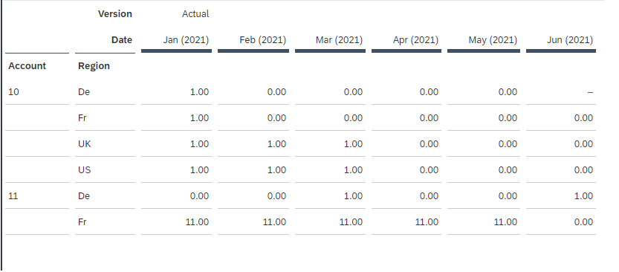

Example 1: You want to delete zero value records from a public version

Create a data action with the following code:
IF RESULTLOOKUP() = 0 THEN // Condition to check data is valid or not
DELETE() // once deleted cannot revert back if version is published
ENDIF

Execute the data action to delete all zero value records across the account and time dimensions. Publish to make the change effective for the public version.
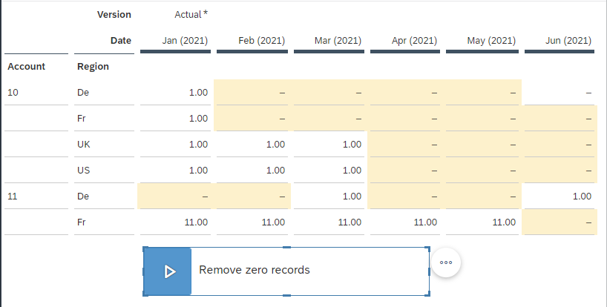

Example 2: You want to delete values from a specific account 10.
The data action can be extended with member set:

MEMBERSET[d/Account]="10" // Define scope, if required

IF RESULTLOOKUP() = 0 THEN // Condition to check data is valid or not
DELETE() // once deleted cannot revert back if version is published
ENDIF

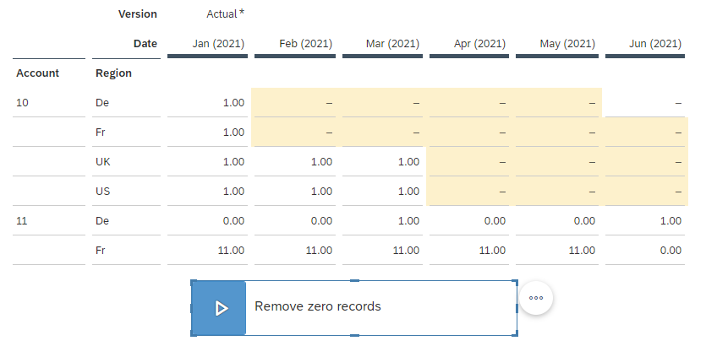

Example 3: You want to delete zero value records from Account = 10 and Date in 2021, second quarter (Apr, May, Jun).

MEMBERSET[d/Account]="10" // Define scope, if required
MEMBERSET [d/Date] = ("202104", "202105", "202106")

IF RESULTLOOKUP() = 0 THEN // Condition to check data is valid or not
DELETE() // once deleted cannot revert back if version is published
ENDIF

