- The applicants Contact email address appears in the following sections :
- Candidate profile. (Screen shot 1)
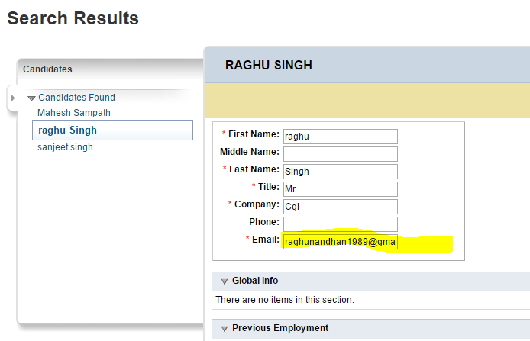
- Business Card/Quick Card (Screen shot 2)
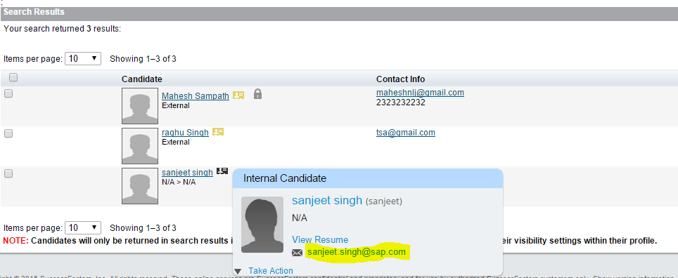
- Appears as a standard column/part of the Contact Info on the candidate search results. (Screen shot 3)
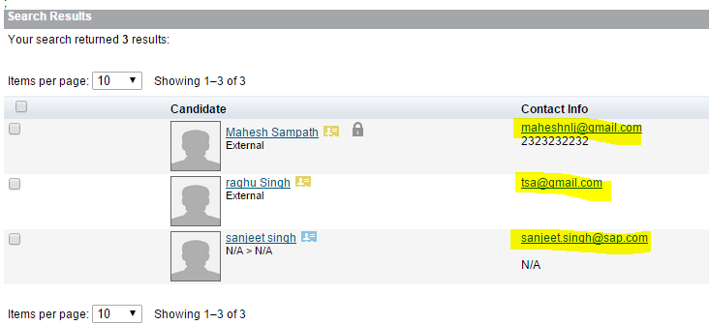
- The applicants Primary email address for both Internal and External candidates can be viewed/edited in the candidate summary page.
(Screen shot 4)
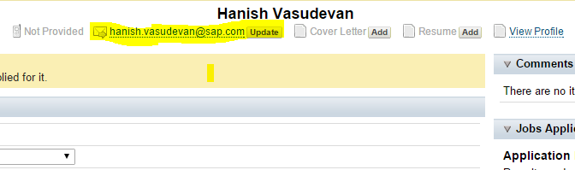
- Internal candidates can login as themselves and view their email address in Employee Profile
(Screen shot 5)
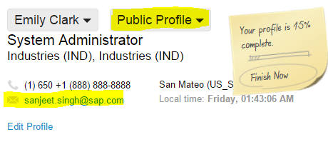
- In Talent Profile . (Screen shot 6)
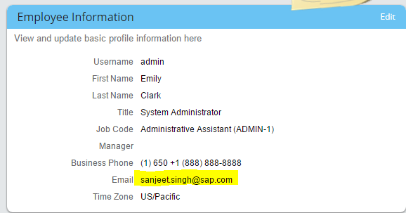

- External candidate can View/Edit the email Id in External Candidate profile page.
(Screen shot 7)
